North Yorkshire Council Launch campaign – Parish and Town Councils Communications Pack

Thank you for helping is to create awareness of the new North Yorkshire Council. We’re grateful for your support in maximising the reach of these messages through your own channels and platforms.

Overview of campaign
This communications pack provides you with a background to the launch of the new council – North Yorkshire Council. Within this pack you will find:
- Background
- Communications toolkit including:
  - External communications for newsletters, websites etc
  - WhatsApp messages
  - Appendix – FAQs
  - Appendix – Social media assets

We would appreciate your support in reaching your communities to ensure all residents understand the benefits of a unitary council, and are reassured there will be business continuity.
If you need any further information or have a question, please contact Rebecca Proctor E: Rebecca.proctor@northyorks.gov.uk or Caroline Harrison-Jones, E: caroline.harrison-jones@northyorks.gov.uk .

Background
On 1 April, the county council and seven district and borough councils in North Yorkshire will become one – North Yorkshire Council.
North Yorkshire Council will be the geographically largest council in England. It is being built with local at its heart and aims to be the most local, large council in the country.
Our staff who currently serve residents will continue to provide the services that they deliver now. A main office will be retained in each former district area and will be supported by a further 30 local customer access points in places people go in the future. There will be one phone number and one website, making sure access to support and services will be easier whilst ending the current confusion that exists over which council does what.
By replacing eight councils with one, it gives North Yorkshire Council the best possible chance of protecting our valued services at a time of exceptional financial pressures and high demand. By joining up services and maximising our spending power, we will save between £30 million and £70 million which will then become annual savings. This money can be used to protect some of our most important local services at a critical time when everyone and every organisation is feeling the pressure.
North Yorkshire Council will drive for the best possible opportunities for residents and businesses, while protecting and enhancing our landscapes and heritage. Working with our six MPs, the Council will have a strong voice to ensure that national Government understands and acts on the issues that affect residents and businesses here.
By having one council we can join up and strengthen our county’s cultural offer, lobby for a greater share of funding for arts and culture, and support a year-round visitor economy. It will have a clear economic strategy that plays to our strengths and supports environmentally friendly business growth.

Contacting North Yorkshire Council
How will we contact officers of the new council?
You should continue to contact council officers through their current email address e.g., firstname.surname@harrogate.gov.uk. From 1 April, any emails sent to these addresses will be automatically forwarded to a new @northyorks.gov.uk email address.
How will we contact Customer Services?
From 1 April 2023 there will be one phone number and one website. Details of these will be communicated nearer the time across various channels.
How will we contact Planning?
You should continue to use the contact details you have currently. There will be one website for the North Yorkshire Council which will contain information from the current county and district/borough councils on the services they manage, including Planning.

Parish Charter consultation
The development of a Parish Charter, defining the relationship between the new North Yorkshire Council and the parish sector as well as setting out how North Yorkshire Council and parishes will work together, is a priority for the new authority. A 12-week consultation launched on 18 January, and all parish clerks have been contacted to a coordinate single response from each parish council by 12 April 2023.
We are running drop-in sessions for Parish Councils across the county during February where you can discuss anything relating to the new North Yorkshire Council.
Visit https://www.northyorks.gov.uk/parish-charter-consultation for more information on the consultation and drop-in sessions.

The Campaign – North Yorkshire Council
The communications plan will launch the new council beginning the week commencing 23rd January, in line with the new council plan being considered at the Council Executive. It will run until June 2023. The campaign will aim to:
- Create awareness of the new council and benefits of unitary
- Reassure residents about business continuity for day one, to support trust and confidence
- Inform audiences about how to contact the new council
- Ensure residents and businesses have information they need relating to any service change linked to Easter weekend and beyond

Copy for websites/newsletters
- For use from 23rd January
- Content links to www.northyorks.gov.uk/newcouncil
- QR codes can be supplied for printed material - – please email Rebecca.proctor@northyorks.gov.uk

On 1 April, the county council and seven district and borough councils will become one – North Yorkshire Council.
The council will become the geographically largest council in England but is being built with local at its heart and aims to be the most local, large council in the country.
It is committed to working closely with town and parish councils, as well as wider partners and communities to ensure that local priorities drive locally led decision-making and local action via community networks.
Staff who currently serve residents will continue to provide the services that they deliver now. A main office will be retained in each former district area and will be supported by a further 30 local customer access points in places people go in the future. There will be one phone number and one website, making sure access to support and services will be easier whilst ending the current confusion that exists over which council does what.
By making this change now, it gives North Yorkshire Council the best possible chance to protect our valued services at a time of exceptional financial pressures and high demand. Joining up services will allow the council to maximise spending power, meaning there is potential savings of between £30 million and £70 million which will then become annual savings. This money can be used to protect some of the most important local services at a critical time when everyone and every organisation is feeling the pressure.
The Council will have a strong voice and will work with the county’s six MPs to ensure that Government understands and acts on the issues that affect residents and businesses. It will advocate for the best possible opportunities. A clear economic strategy that plays to the county’s strengths and supports environmentally friendly business growth means it will be business friendly. By having one council, we can strengthen the county’s cultural offer, lobby for a greater share of funding for arts and culture, and support a year-round visitor economy.
To find out more, visit www.northyorks.gov.uk/newcouncil
WhatsApp messages
You may be a member of a local neighbourhood WhatsApp group, or perhaps just want to inform family and friends. Please see below suggested copy:
- North Yorkshire Council will replace the 8 existing councils from 1 April. To find out more visit www.northyorks.gov.uk/newcouncil

Appendix
Social media assets
If you have social media accounts for your parish council, below you will find a series of messages you may wish to post to inform residents about North Yorkshire Council.
We will be sharing information about the new council across our social media accounts (County Council and the District and Boroughs) which you may wish to share.
- For use from 23rd January
- We want to create awareness that the new council is coming and the benefits that will bring to them and the county.
Key points throughout this phase:
- One council for North Yorkshire delivering all current district and county services
- We will be in a stronger position to work together to get the most from every North Yorkshire pound
- #NorthYorkshireCouncil
You can download the social assets detailed via the following link: https://we.tl/t-J3nYKqesgh

Topic & image | Copy
New council launching 1 April  Image: Collage with NYC logo  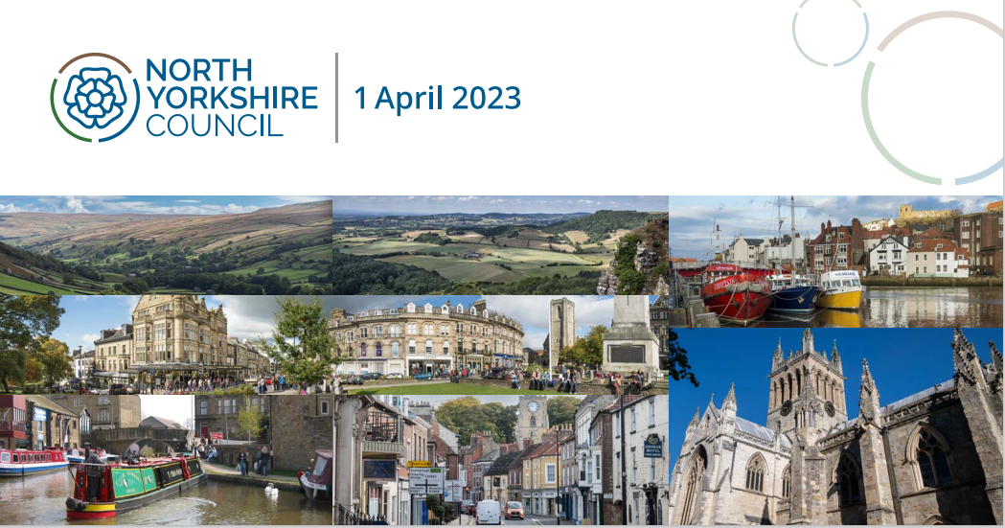 | Facebook/Instagram:  The new North Yorkshire Council launches on 1 April, joining together the existing eight local councils and providing a once-in-a-lifetime opportunity to help tackle some of the biggest challenges faced across the county. Creating new jobs, tackling climate change and building affordable homes will be among the key priorities for the council.  Find out more about North Yorkshire Council at https://www.northyorks.gov.uk/news/article/communities-will-be-heart-new-council  Twitter:  North Yorkshire Council launches on 1 April, joining together eight existing councils. Creating jobs, tackling climate change and building affordable homes are among the council’s priorities. Read more https://www.northyorks.gov.uk/news/article/communities-will-be-heart-new-council
Benefits  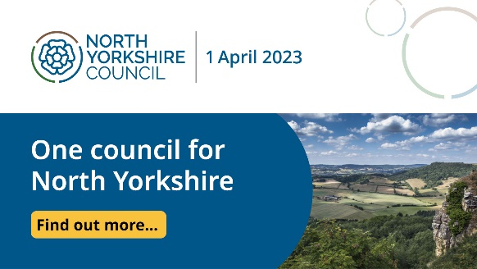 | Facebook/Instagram:  North Yorkshire Council launches 1 April, combining the eight existing county, district and borough councils in North Yorkshire.  Having one council will end confusion over which authority is responsible for which service, plus with one set of councillors who will be accountable for the whole county it will be clear to see who represents your local community.  Find out more at www.northyorks.gov.uk/newcouncil  Twitter:  North Yorkshire Council launches on 1 April, joining together eight existing councils. One council will end confusion over which authority is responsible for your services, plus there will be one set of councillors for the whole county. Read more www.northyorks.gov.uk/newcouncil
Finance and budget for the new council-services:  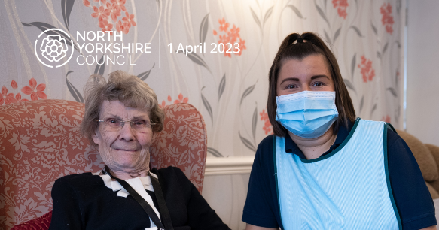 | Facebook/Instagram:  The new North Yorkshire Council will be the geographically largest council in England. By joining up services and maximising spending power, the new council will save between £30 million and £70 million in the first few years, which will then become annual savings. This money can be used to protect some of the most important local services at a critical time when financial pressures are high.  Find out more about the new council, which launches on 1 April, at www.northyorks.gov.uk/newcouncil  Twitter:  By joining up services and maximising spending power, the new North Yorkshire council will save between £30-£70 million which can be used to protect some of the most important local services at a time of high financial pressure. Visit www.northyorks.gov.uk/newcouncil
Reassurance customer messaging  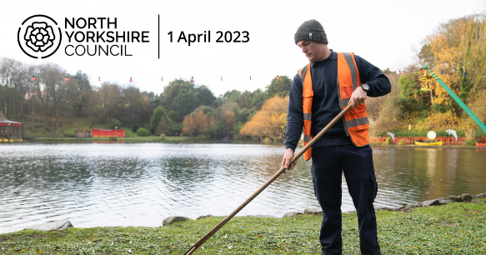 | Facebook/Instagram:  With the launch of North Yorkshire Council on 1 April, all existing eight councils across the county have already been working together to establish how best services can be provided, while ensuring business continues as usual. This means you will see minimal change as services and staff are brought together in the background.  You will still be able to access the same support and advice from local staff who live and work in the area, with an office in each former district area supported by a further 30 access points in the future.  Find out more about the new council, which launches on 1 April, at www.northyorks.gov.uk/newcouncil  Twitter:  All eight councils in North Yorkshire have been working together to ensure services continue as normal on 1 April when North Yorkshire Council launches so you will see minimal change as they bring services and staff together. Read more www.northyorks.gov.uk/newcouncil
Climate  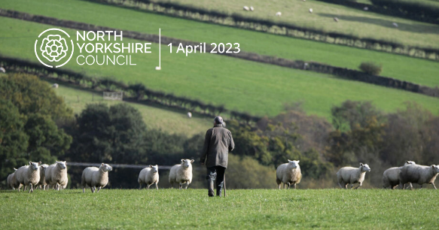 | Climate change is one of the biggest challenges faced both nationally and internationally, and North Yorkshire is being placed at the forefront of the task of tackling it. A climate change strategy is set to be introduced by the new North Yorkshire council, with the ambition of making the county the first “carbon negative” region.  North Yorkshire Council launches on 1 April and will also be focused on growing job opportunities in the green sector while preserving the county’s prized natural habitats.  Find out more about the new council at www.northyorks.gov.uk/newcouncil  Twitter:  A climate change strategy is set to be introduced by the new North Yorkshire council, with the ambition of making the county the first “carbon negative” region and growing jobs in the green sector while preserving natural habitats. Read more at www.northyorks.gov.uk/newcouncil

Frequently Asked Questions
The new council will cover the largest geographical area of any authority in the country. How can you make sure that you still serve local communities properly?
The new council will have local at its heart, with staff continuing to live and work in the communities they serve. Access to support and services will be easier, via one telephone number, one website, one customer service team and one set of face-to-face customer access points spread across the whole county. There will be a main office in each former district area, and are committed to expanding this network so there will be around 30 additional customer access points where you can get advice and support, either in or close to the area you live or work.
What will happen to the services I use every week, such as bin collections, schools, leisure centres and libraries, when the new council launches?
You will not notice minimal changes in the spring to the council services that are being provided at the moment. Whether that is having your bins collected, visiting your local library or how your child is taught at school, these services will not change when the new council launches on April 1, 2023. Colleagues across the county council and the seven district and borough councils are working very closely together to make sure that all services are unaffected and continue for the public.
What will happen to my local council building?
Your local council building will continue to deliver services. This includes a main office in each former district which will continue to give advice and face to face expertise. In addition to this many areas also have a local office – often a library, where they can also obtain advice and assistance to access council services, and this will not change. We are also committed to expanding this network so there will be a network of around 30 customer access sites where you can get advice and support, either in or close to the area you live or work in the future.

How will I contact the new council?
There will be one website and one phone number for the new council, as well as council buildings in each district (see above) where you can seek face-to-face guidance. We are also committed to expanding this network so there will be a network of around 30 customer access sites where you can get advice and support, either in or close to the area you live or work.

What is a community network?
Community networks are likely to look different in different places but will share some common principles such as being based in market towns and their natural hinterlands. They will be subject to consultation with local communities and will build on existing assets. It is expected that the nature and make up will evolve and flex over time to meet local needs and priorities. They will bring together a range of stakeholders that reflect that place and operate independently, having autonomy to elect their own Chair and agree their own priorities and plans. They will be able to influence strategic decisions that affects their communities and be supported to explore funding opportunities from a range of sources and opportunities to align partner investment in their communities.

How will the new council work with partners and parish and town councils?
The new council will work closely with town and parish councils, wider partners and communities to ensure that local priorities drive locally led decision-making and local action via community networks.

How will North Yorkshire Council save between £30 million and £70 million per year?
By joining up services and maximising spending power. These will be annual savings which can be used to help protect some of the most important local services at a critical time when everyone and every organisation is feeling the pressure from increased costs.

Why is my council tax bill going up when we are supposed to be seeing savings of up to £70 million a year with the launch of the new council?
The new council will give us the opportunity to save millions of pounds by streamlining operations currently overseen by the eight local authorities in North Yorkshire. However, there are really tough financial decisions ahead as we are facing the highest rates of inflation for more than 40 years nationally along with the cost-of-living crisis, which is affecting everyone. The new council will have an overall spending power of about £1.4 billion including £343 million on schools but rising costs and demand for services means it already faces a funding gap of £30 million this year alone. Council tax is now the most important source of funding for services in North Yorkshire, and each one percent increase would raise £4 million towards meeting rising costs and demand.

Why am I going to have to pay more council tax than my current bill when people living in other areas in North Yorkshire are going to be able to pay less?
The new council’s launch means that all council taxpayers in North Yorkshire legally have to be charged the same amount. The job of standardising all council tax bills across the seven districts in North Yorkshire is set to be phased in over the next two financial years, as some areas are paying higher rates than others. By making council tax bills the same, it will mean the fairest system for all taxpayers in the county. A cross-party working group formed of councillors from the county, district and borough councils recognised the financial demands that are being placed on households during the cost-of-living crisis. They agreed the fairest and most efficient way forward was for the harmonisation of council tax to take an average of all existing bills and implement the changes across two financial years.

The cost-of-living crisis is affecting everyone. Why do you need to create a new council when money could be spent on helping those most in need in North Yorkshire?
Everyone is feeling the effects of the rising cost of living, especially on food and other essential items. But the current structure with the county council and the seven district and borough authorities in North Yorkshire is not seen as a sustainable way to deliver important services in the long-term. By creating the new North Yorkshire Council, millions of pounds can be saved to help fund these services. Having one council will save between £30 million and £70 million a year. This is money that can be used to help to protect some of the most important local services at a critical time when everyone and every organisation is feeling the pressure from increased costs. There will be tough financial decisions ahead, but by making this change now, we are better placed to manage the impacts. We are also in a stronger position to work with partners like the health sector, police, fire, and community and voluntary sector to get the most from every North Yorkshire pound. We are also taking steps to help those most in need. Councillors have voted to back proposals which will provide up to 100 per cent reductions on council tax bills for households on the lowest incomes.
Why do we need to create a new council to get devolution – can’t we just have devolution without merging the eight authorities into one?
We were told by the Government that the current structure of local government – with the county council and the seven district and borough authorities – had to be replaced with a unitary authority to secure a long-awaited devolution deal. This will make local democracy in the county much simpler, and end confusion over which council does what, and which councillor is responsible for which area. It also gives us the chance to streamline services and make millions of pounds of savings which will be used to finance key priorities of the new council. Having one council will save between £30 million and £70 million a year. City of York Council will continue as a separate unitary authority to run alongside the new North Yorkshire Council, which will launch on April 1, 2023.
What is devolution and what benefits would it bring for people living and working in North Yorkshire?
Devolution is a key policy of the Government, handing over decision-making powers to local political leaders and providing millions of pounds in funding to shape hugely important policies and projects at a regional level. A proposed 30-year devolution deal for York and North Yorkshire, with an investment fund of £540 million, is due to lead to benefits ranging from new and better-paid jobs and improved transport links to more affordable housing. The proposed deal was unveiled on 1 August, with the option to elect a regional mayor in May 2024, giving York and North Yorkshire a direct relationship with central Government. Staff will continue to be based locally to work with communities and ensure that their needs can be effectively served.

